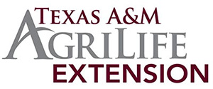
Texas A&M AgriLife Extension
2022 Frio County Annual Report
Texas A&M AgriLife Extension is dedicated to serving & educating Texans for over 100 years since the establishment of the 1914 federal Smith-Lever Act. AgriLife Extension and the utilization of land-grant university research continues to provide all Texans with beneficial research-based knowledge beyond the laboratory and classroom, into everyday living. The continued support of the Frio County Judge, Commissioners Court, and local volunteers/sponsors contributed to the success of all 2022 Frio County AgriLife Extension Programming.

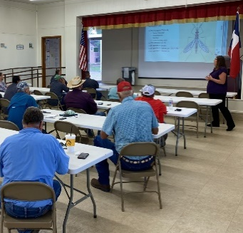
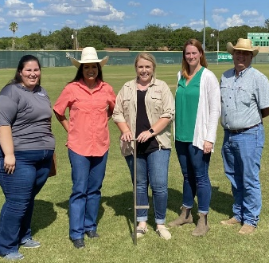
Agriculture & Natural Resources: Crop & forage production are the mainstays in agricultural production systems in Frio County. To allow for better management practices to increase overall profitability for the individual farming & ranching operations in Frio County, several educational activities were approached to address these current related issues. An approximate 87% economic benefit was reported by attendees from these educational programs. Below, are program and agent successes of 2022.
2022 Insect and Turf Grass Management Workshop- June 2, 2022, this multi-county CEU educational program was conducted at the Atascosa County Extension office and hosted by Frio, Wilson, and Atascosa counties. Dr. Chrissie Segars, Extension Turf Grass Specialist, and Sonja Swiger, Extension Entomology Specialist addressed disease management, vector control, insect management, weed management, varieties update, and fertilizers for 16 program participants. 92% of respondents were mostly or completely satisfied and 87% anticipate benefitting economically.

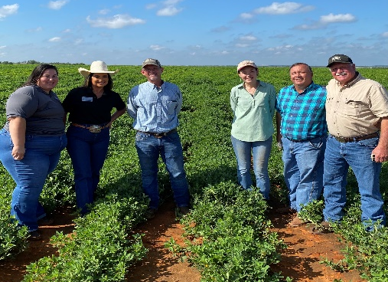
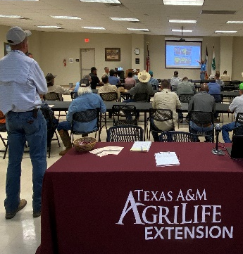
2022 South Texas Peanut Growers Annual Peanut Tour: September 22, 2022, educational program and tour focusing on Peanut Breeding Trials & Upcoming Releases, Peanut & General Weed Control, and 2022 Peanut Variety Performance for 24 agricultural producers. Speakers- Dr. John Cason, Dr. Josh Mcginty, Dr. James Grichar, and Dr. Emi Kimura, State Extension Peanut Specialist. 74% of attendees increased their understanding in Peanut Herbicides. 87% of respondents anticipate benefiting economically.

2022 Fall Multi-County Private Water Well Screening: The County Extension Offices of Frio, Atascosa, La Salle, Dimmitt, Zavala, and McMullen conducted a private water well screening at the Frio County Extension Office on October 12, 2022. A total of 44 samples were screened for bacteria, nitrates, salinity, and hydrocarbons.

Last Chance Videos- 4 CEUs Offered: Conducted on November 22, 2022, at the Frio County Extension office, 9 Private Pesticide Applicator holders obtained a total of 4 CEU credits as they watched two sessions of the Last Chance Videos offered by Texas A&M AgriLife Extension. These videos consisted of four educational hours of Laws and Regulations and Integrated Pest Management.

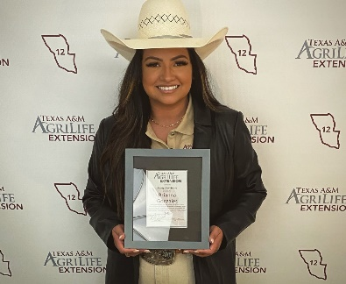
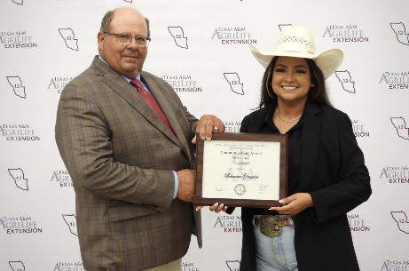
CEA Brianna Gonzales pictured on the right after receiving the Rising Star Award at the 2022 District 12 Fall Faculty Conference.
On the left, agent received the 2022 Texas County Agricultural Agents Association Communications Award for Third Place Newsletter at South Padre Island, Texas. This award was presented by TCAAA President, Stephen Zoeller.

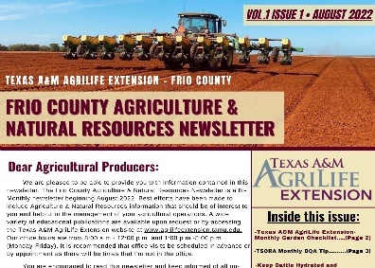
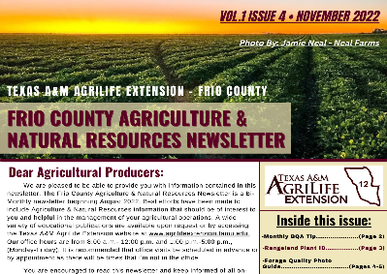
Frio County Agriculture & Natural Resources Newsletter: The Frio County Agriculture & Natural Resources Newsletter is an educational newsletter focusing and addressing relevant/current general agriculture and natural resources information that should be beneficial to all Frio County Agricultural producers. This newsletter also includes upcoming Frio AgriLife Extension Events. This monthly newsletter reaches approximately 700 individuals.

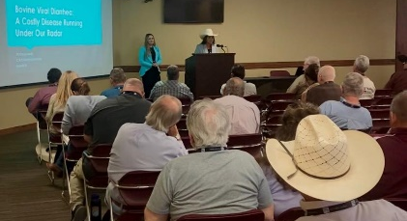
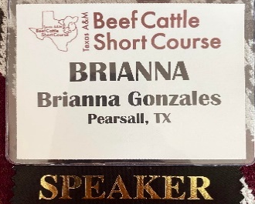
2022 Texas A&M Beef Cattle Short Course- Agent was given the opportunity to attend this years Texas A&M Beef Cattle Short Course as well as given the opportunity to moderate the Beef Cattle Health Session that was conducted on August 2, 2022. Agent introduced all the speakers for this session along with their educational presentations to over 200 beef cattle producers from across the state of Texas.

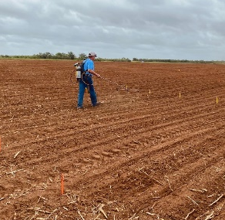
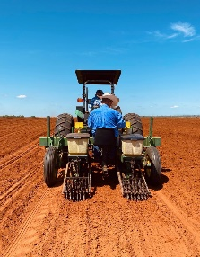
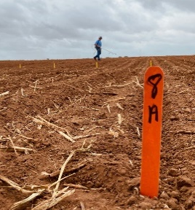
Frio County Result Demonstration Work: Demonstration and applied research was conducted in Frio County in the towns of Dilley, Derby, and Pearsall. Agent took part in assisting with Peanut Breeding Trials, Peanut Variety Trials, and Peanut Herbicide Trials. Texas A&M AgriLife Research & Extension Specialists from the Corpus Christi and Stephenville centers assisted in conducting these demonstration and research trials.

4-H Youth & Development in Frio County:
The 4-H Youth Development program helps young Texans to acquire knowledge, develop life skills, and form attitudes to enable them to become self-directed, productive, and contributing members of our society. Although COVID-19 had an impact on our everyday lives, it did not prevent the youth of Frio County from having another successful year. As of May 31, 2022, agent was new to Frio County and has utilized the duration of the year to meet the community, key stakeholders, and the youth and adults of Frio County 4-H. Many efforts and accomplishments were met by the determination from Frio County 4-H club members, volunteers, collaborators, and the community. Below, are some of the many highlights and outcomes of the 2022 Frio County 4-H year.
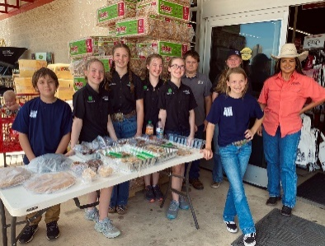
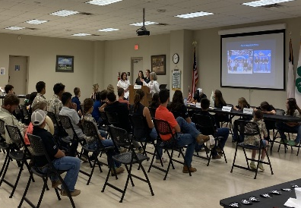
Frio County 4-H Community Service & Club Meetings: Agent is new to Frio County and was eager to begin establishing herself within the county. With 4-H job duties and responsibilities, agent began to meet and support Frio County 4-H Clubs and their members. Agent has attended 4-H club community service events and has attended monthly 4-H club meetings throughout the duration of the year.

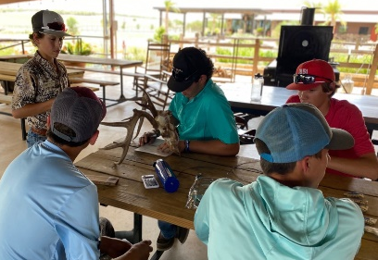
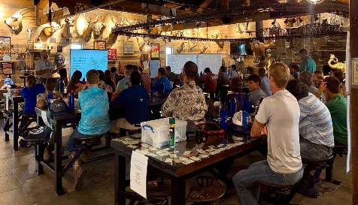
2022 South Texas Buckskin Brigades: Agent attended and assisted during the 2022 South Texas Buckskin Brigades that was conducted June 12-16, 2022, at the G2- Ranch in Pearsall, Texas. Over 70 youth participated in this youth camp that focused on the importance of range, wildlife, agriculture, and natural resources.

Dilley Independent School District Back 2 School Bash: Agent attended the 2022 Dilley ISD Back 2 School Bash that was conducted on August 2, 2022, at the Dilley Elementary School. Agent was able to meet with over 80 youth and adults to discuss all the great opportunities that Texas 4-H has to offer. Agent also encouraged local 4-H member enrollment and discussed the wide variety of Texas 4-H project areas that youth can participate and compete in at the county, district, state, and national levels.

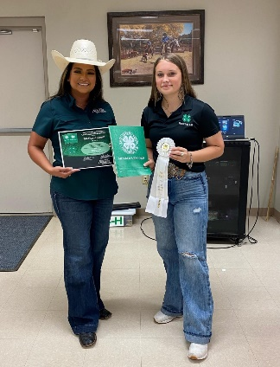
Frio County 4-H District & State Events: Frio County 4-H club members competed in District 12 4-H and Texas 4-H State Events throughout the duration of the 2021-2022 4-H year. Agent was able to provide educational support, assistance, and guidance to those participating in these events. Frio County 4-H club members participated in District 12 4-H Photography Contest, District 12 4-H Record Book, District 12 4-H Election Convention, District 12 4-H Livestock Judging Contest, District 12 4-H Horse Judging Contest, and State Texas 4-H Roundup.
Frio County 4-H Clubs- Dilley 4-H, Mavericks 4-H, Pearsall 4-H Claybusters 4-H, and Frio County 4-H Council.
4-H Club Members- 155 4-H Adult Volunteers- 28

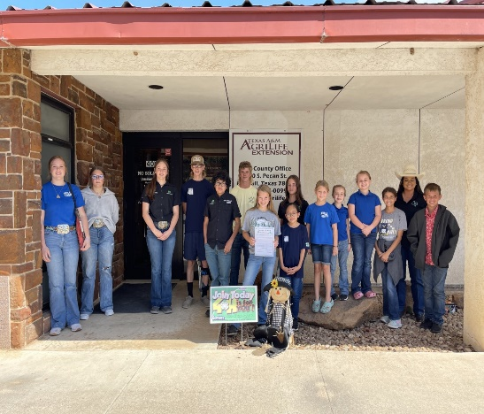
Frio County 4-H National 4-H Week and One Day 4-H Community Service Event: The Frio County Judge and Commissioners Court declared October 2-8, 2022, as National 4-H Week in Frio County. Frio County 4-H Clubs had many One Day 4-H ideas and the Frio County 4-H Council decided to conduct a toy drive as their One Day 4-H community service event. Toy drives were held in Dilley and Pearsall, along with many drop boxes that were placed all over the county. Over 100 toys were collected and provided to local churches to distribute to families in need of Christmas presents and cheer.

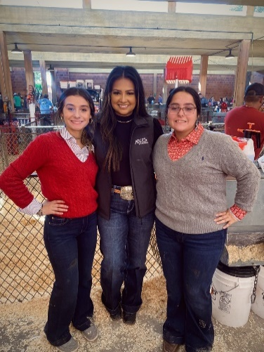
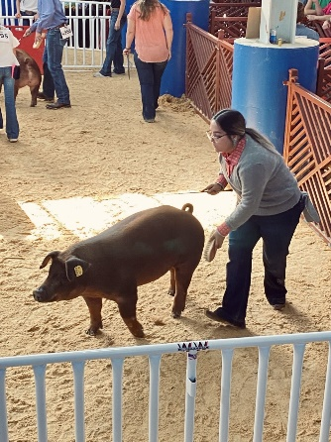
Frio County 4-H takes on the 2022 State Fair of Texas: Agent attended the 2022 State Fair of Texas as a couple of Frio County 4-H members exhibited their livestock projects for the first major show of the year. Agent provided support and guidance to exhibitors of the Dilley 4-H Club. These exhibitors showed their swine projects and stated that this was their first time showing at the State Fair of Texas. Unfortunately, they did not place, but they did have a great time showing their projects and really enjoyed their experiences by attending this show.

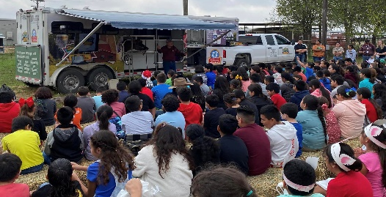
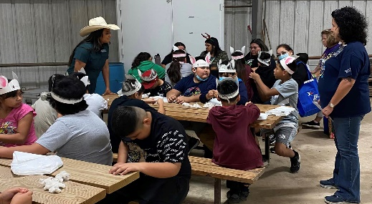
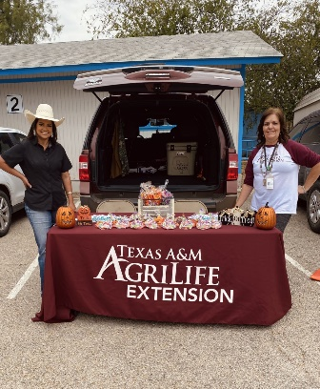
Frio County Youth Ag Day: The Frio County Youth Ag Day educational event has been an annual event but has been postponed since 2020 due to the rise of Covid-19. This educational event was a collaborative effort with local ag agencies that included Texas Farm Bureau, Tellus John Deere, Medina Electric Company, Mann Farms, Texas Parks & Wildlife, Southwest Dairy Farms, and local 4-H/FFA. 4th graders from Pearsall and Dilley were educated on agricultural related topics which included high voltage electricity, dairy, tractors, rainfall, goats, farm safety, cotton, peanuts, bees, feed grains, beef, and 4-H/FFA/TP&W. Over 200 students participated in this educational activity.

Frio County 4-H Outreach: Frio County 4-H Clubs, adult 4-H volunteers, and local Extension staff participated in numerous community outreach and community service events throughout the duration of the year. These monthly opportunities provide opportunities to club members as they recruit and speak with the youth of Frio County on the many opportunities Texas 4-H has to offer. Extension staff have the opportunities in meeting more of the community and discuss the services we have to offer within Extension.

